
United International University

Dept. of Electrical & Electronics Engineering

Four Way Traffic Light Controller Circuit using 555 Timer IC and CD4017

Course: Digital Electronics Lab
Submitted to: Akif Hamid sir

Submitted By:
No. | Name | ID
1. | Sabbir Ahmed | 0212410034
2. | Hasan Rayhan Rabbe | 0212410026
3. | Minhaz Hossain Shemul | 0212330016
4. | Md Eakub Ali | 0212330012
5. | Prikta Sen | 0212330013

Four Way Traffic Light Controller Circuit using 555 Timer IC and CD4017

Introduction:
In modern times, every day the number of vehicles is increasing. We all have seen traffic lights, which placed at road intersections, pedestrian crossing, and other locations to control flows of traffic. These traffic lights are used to avoid traffic jams and accidents on roads. The traffic signal has three different color lights, which indicates three different messages for the drivers, Red for STOP, Yellow for WAIT, and Green for GO.
in this project, we will make a Four-Way traffic light controller Circuit using 555 Timer IC and CD4017 counter IC, which can help us to understand how a traffic light system works. This type of traffic light is placed at the center point of the four-way crossing.

Project Concept:
The key components of this project are Potentiometer, Ne555 timer IC, CD4017 counter IC and LEDs. The NE555 IC works as an astable multivibrator to produce pulses. The time period of these pulses can be adjusted by the Potentiometer. It means the Potentiometer is used to change the shifting time of the Traffic light. Then the output pulse from the NE555 timer IC goes into the clock input of the CD4017 counter IC. Then the counter IC counts pulse and changes the output line (Q) logic into HIGH or LOW. We can obtain traffic signal light by connecting the proper color LED with the counter IC output pins. Here we will use 3 different color LEDs, 4 for each color.

Impact:
This project demonstrates a low-cost, reliable, and hardware-based solution for four-way traffic control. It strengthens understanding of timing circuits and sequential logic while reflecting real-world traffic management principles. The system enhances educational learning, promotes traffic safety awareness, and serves as a foundation for more advanced intelligent traffic control systems.

Components Required:
Components Name | Quantity
NE 555 Timer IC | 1
CD4017 Decade Counter IC | 1
1K ohm Resistor | 1
330 ohm Resistor | 1
100KΩ Potentiometer | 1
10µF capacitor | 1
IN4007 Diodes | 10
Red LED | 4
Yellow LED | 4
Green LED | 4
4v Power supply voltage | 3
Connecting Wire | As required in the circuit diagram

Circuit Truth Table :

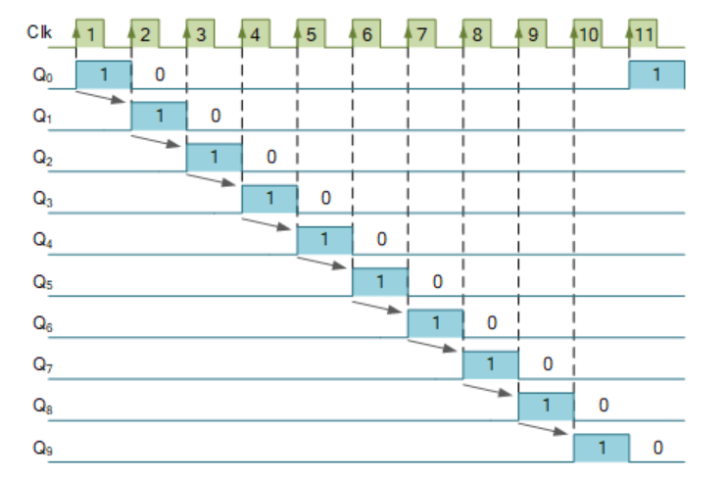

Methodology:
The methodology involves generating clock pulses using a 555 timer, sequencing these pulses through a CD4017 counter, and applying diode-based logic to control traffic light signals. This structured approach ensures safe, automatic, and cyclic traffic control using fundamental digital electronics principles.

Four Way Traffic Light Controller Simulation Circuit Diagram: (Multisim)

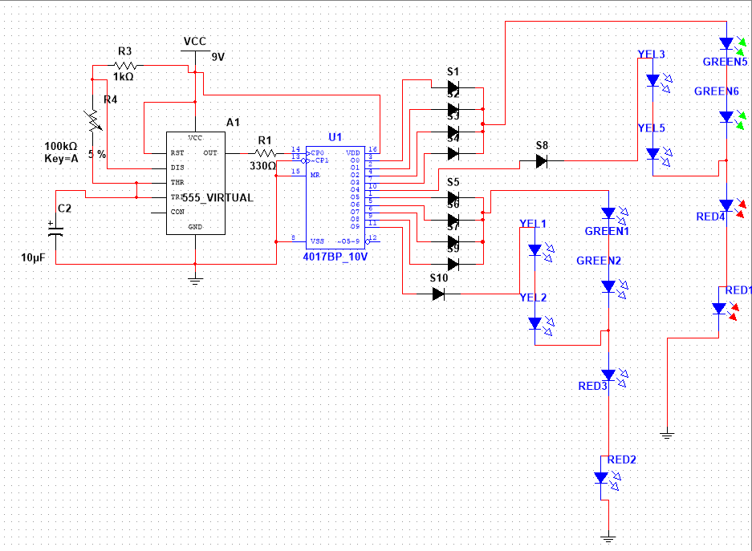

- Fig-1: When, the output of the Q0, Q1, Q2, Q3 pins goes high, then the GREEN LED on NORTH and SOUTH will be ON along with RED LED on EAST and WEST.

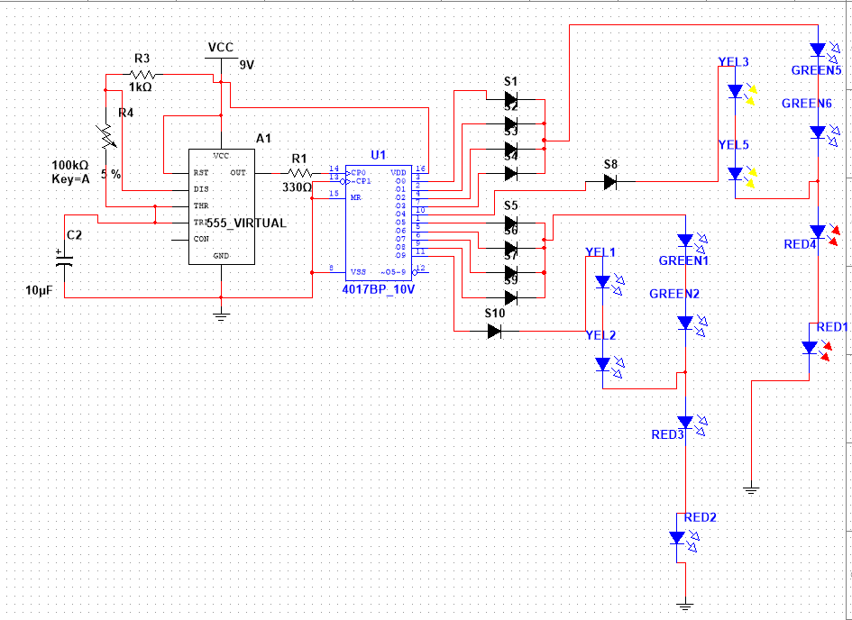

- Fig-2 : When the output of the Q4 pin goes high, then the YELLOW LED on NORTH and SOUTH will be ON along with RED LED on EAST and WEST.

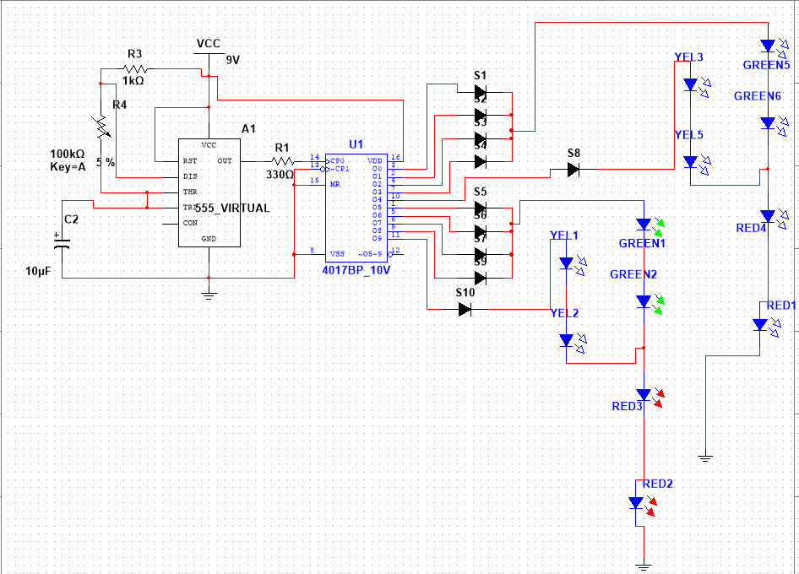

Fig-3: When, the output of the Q5, Q6, Q7, Q7 pins goes high, then the GREEN LED on EAST and WEST will be ON along with RED LED on NORTH and SOUTH.

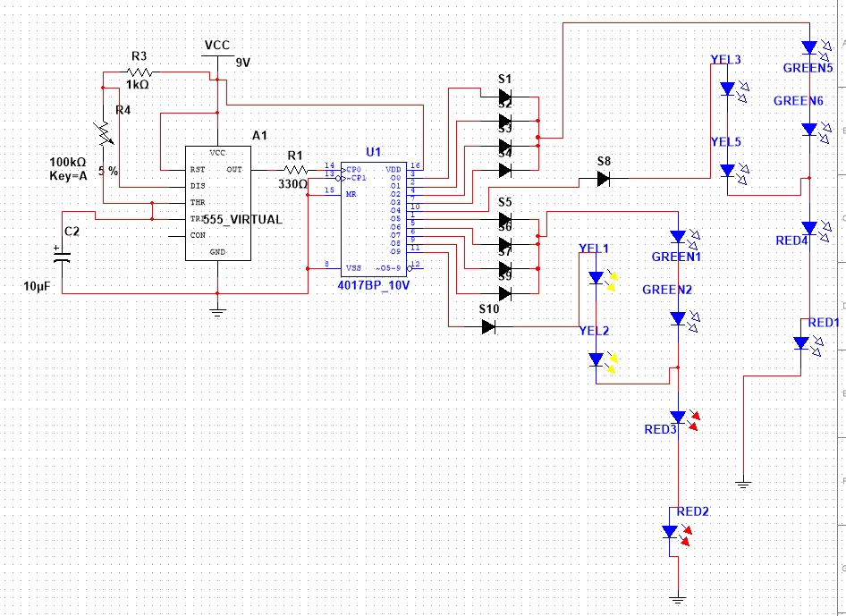

- Fig-4: When the output of the Q9 pin goes high, then the YELLOW LED on EAST and WEST will be ON along with RED LED on NORTH and SOUTH.

Four Way Traffic Light Controller In Breadboard Implementation :

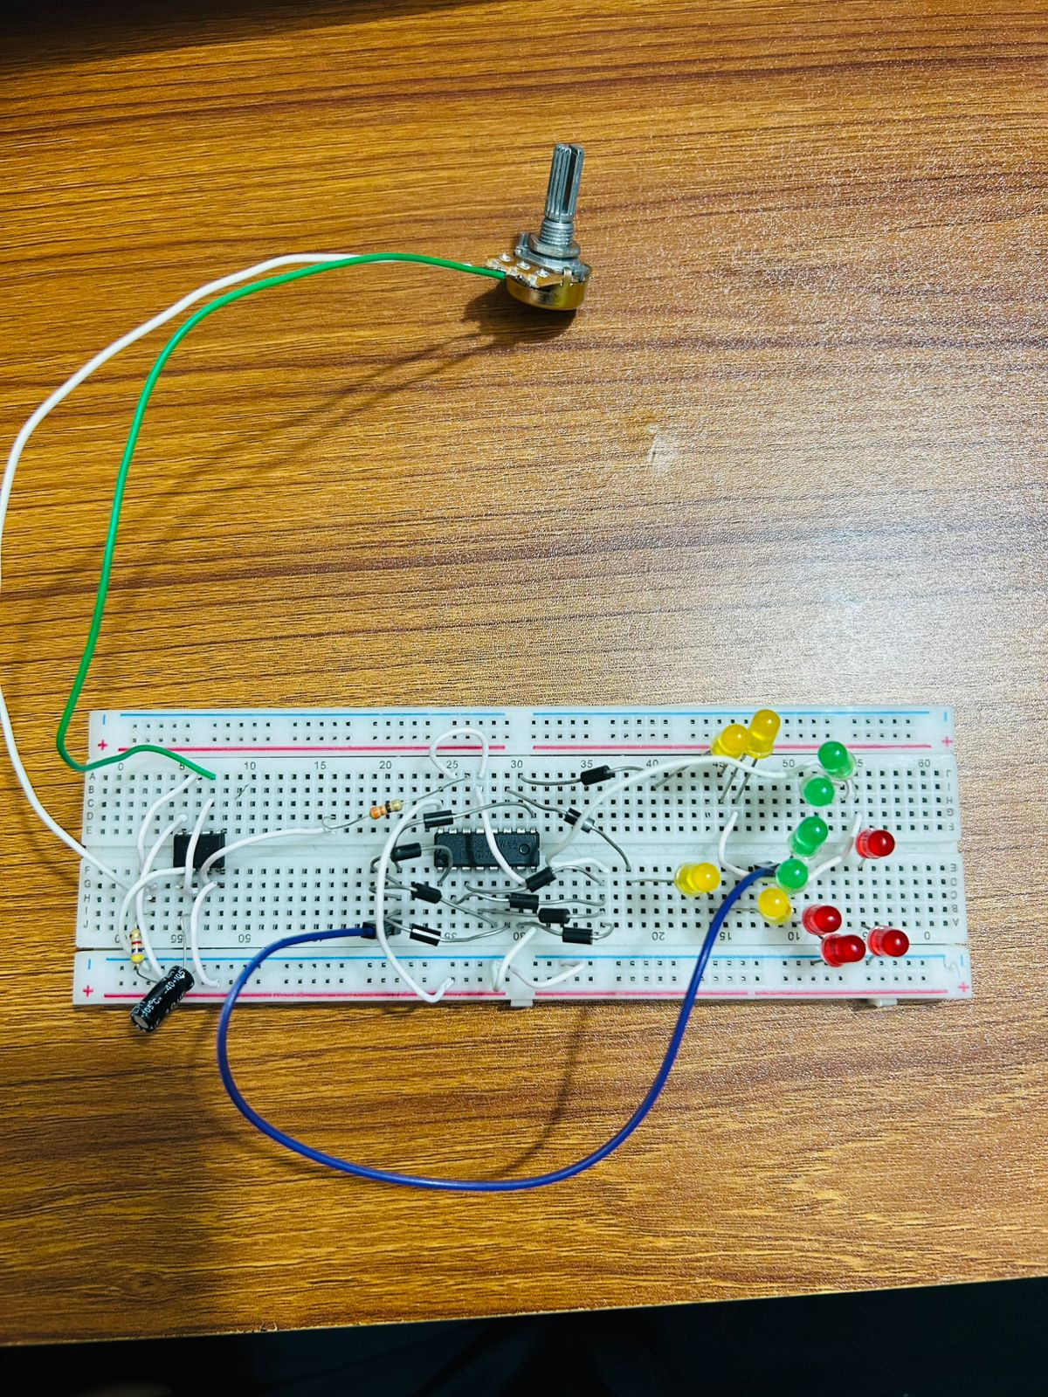

Four Way Traffic Light Controller In VeroBoard Implementation :
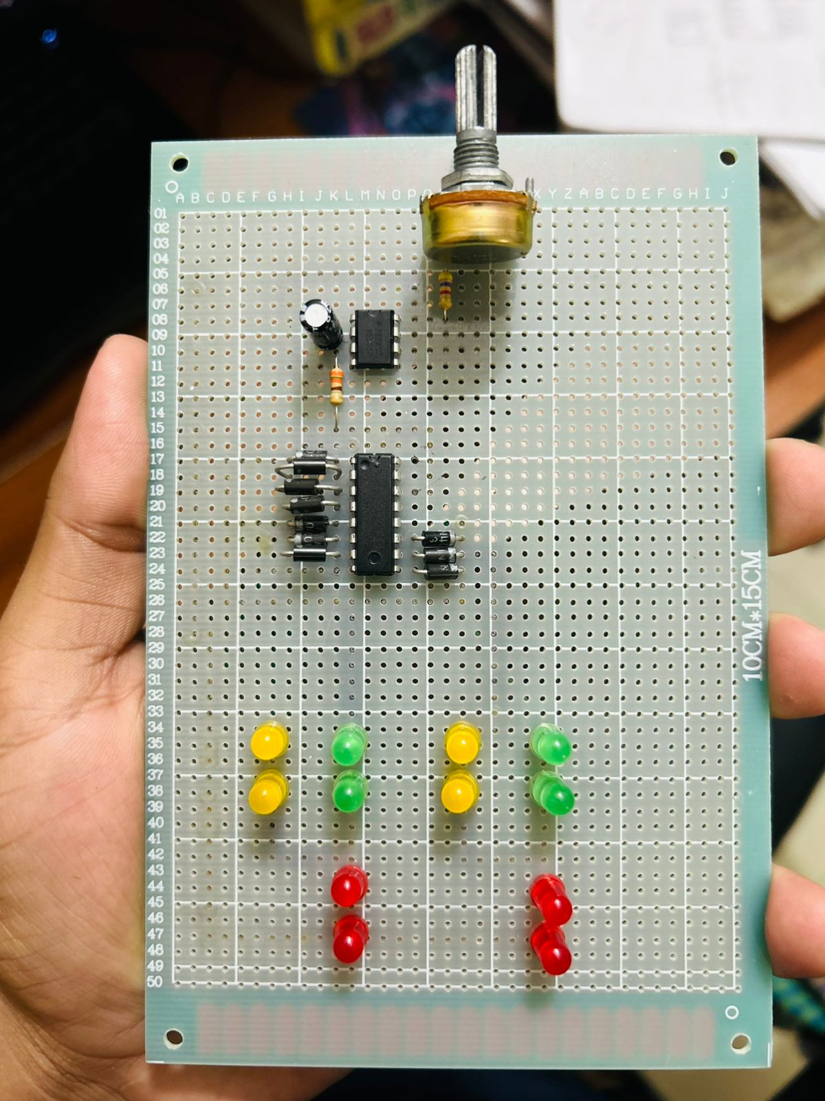
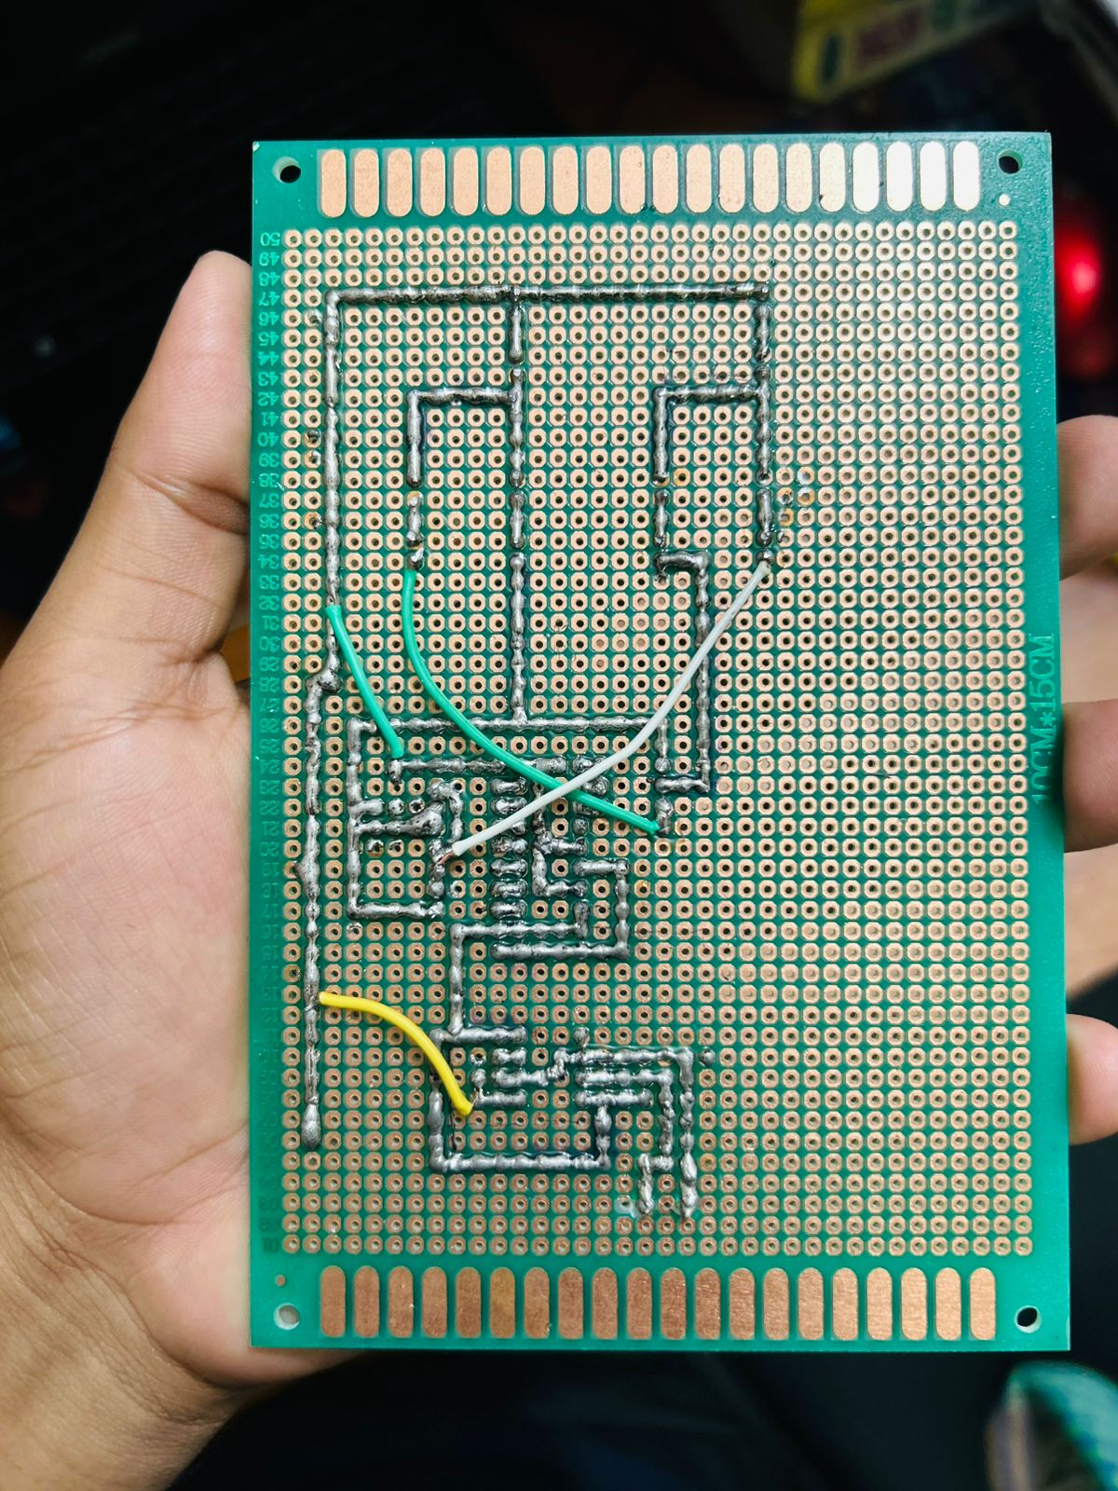

Functional Process of VeroBoard & Breadboard :

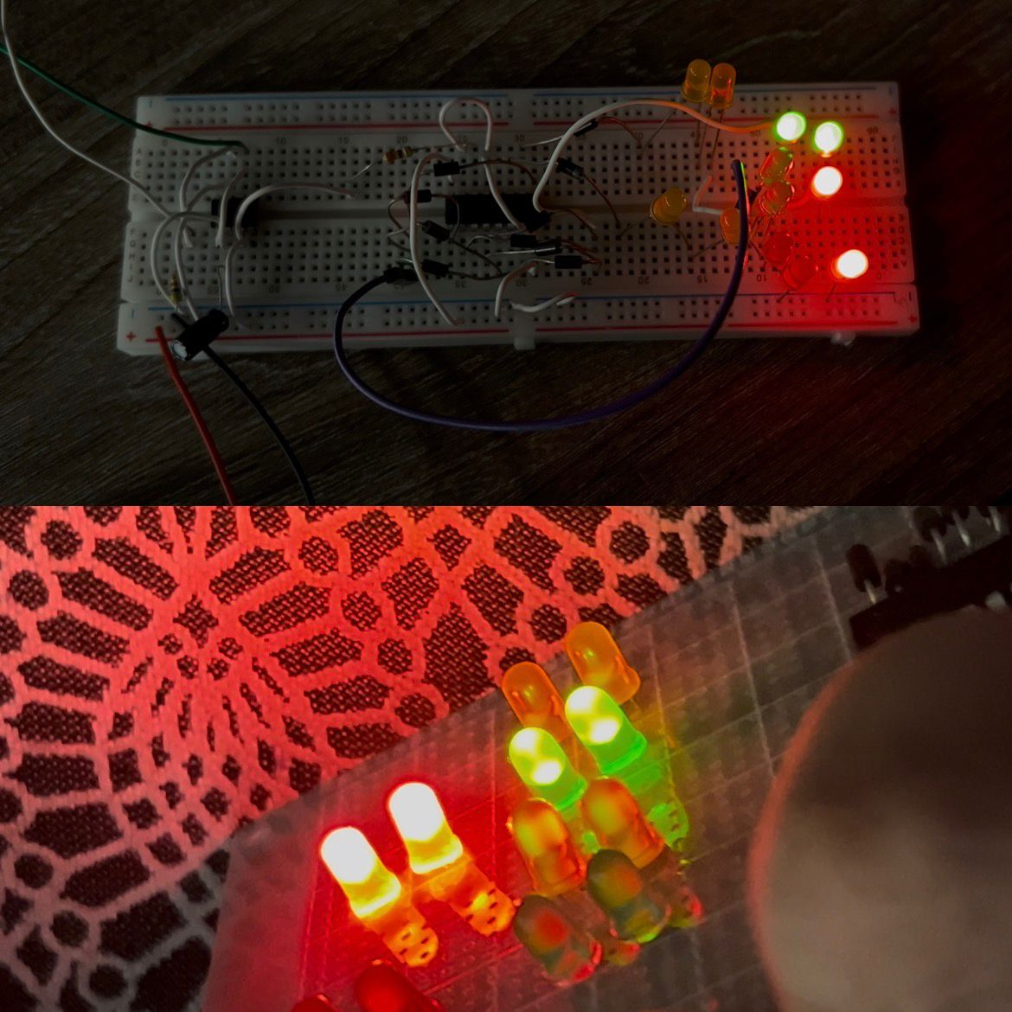

Working Principle of Four Way Traffic Light Controller Circuit using 555 Timer IC and CD4017:

Here the NE555 IC works as an astable multivibrator mode and produces pulses as output. We can change the time period of the output pulses by changing the value of R1, R2, and C1. Here we have replaced the R2 resistance with a potentiometer (VR1). So we can change the time period of the output pulses by rotating the potentiometer knob [Because the resistance (R2) value is change]. So, the 555 timer IC acts as a square wave generator and generated clock pulses. This input change is to change the shifting time of the Traffic light (LEDs).
Then the Clock pulse from the NE555 timer IC goes into the clock input of the CD4017 counter IC. Then the counter IC counts pulse and changes the output line (Q) logic into HIGH or LOW. For example, if the counter IC count is 2 then the Q1 pin of the counter will be high, and if 3 counts the pin Q2 will be high.
The 1N4007 diodes are used to prevent the shorting of counter outputs. For example, if the IC count is 2 then the Q1 will be high, but this time all other outputs will be Low. if we have not used the diodes, Q1 with positive voltage gets hardly pulled down to LOW by Q0, Q2, and Q3 as they will connect together. Then this short circuit takes place.

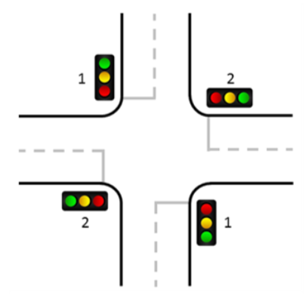
- When, the output of the Q0, Q1, Q2, Q3 pins goes high, then the GREEN LED on NORTH and SOUTH will be ON along with RED LED on EAST and WEST.
- When the output of the Q4 pin goes high, then the YELLOW LED on NORTH and SOUTH will be ON along with RED LED on EAST and WEST.
- When, the output of the Q5, Q6, Q7, Q7 pins goes high, then the GREEN LED on EAST and WEST will be ON along with RED LED on NORTH and SOUTH.
- When the output of the Q9 pin goes high, then the YELLOW LED on EAST and WEST will be ON along with RED LED on NORTH and SOUTH.

Limitations & Future Improvements:

Constant control

No realtime traffic sensing

Sensor based control

Emergency vehicle priority

Microcontroller upgrade

Manual traffic control is prone to human error, fatigue, and inconsistent performance. It lacks accurate timing, struggles with heavy traffic, and increases operational cost. Safety risks to traffic personnel and poor visibility at night further reduce its effectiveness. Therefore, automated traffic control systems are more reliable and efficient.
Conclusion:
The project successfully designed and implemented a four-way traffic control system using basic electronic components without the use of any microcontroller. The system was able to control traffic flow at an intersection by automatically switching traffic signals in a predefined and sequential manner. Proper timing between red, yellow, and green signals was maintained using the NE555 timer and CD4017 decade counter. The project demonstrated reliable operation, reduced the need for manual intervention, and provided a cost-effective solution for traffic signal control at low-traffic intersections.
This project has significant practical importance as it provides a simple and economical solution for controlling traffic at four-way intersections. It can be used in areas with low to moderate traffic volume such as small towns, campuses, industrial zones, and temporary road intersections. The system reduces dependency on traffic police, minimizes human error, and improves road safety. Additionally, the project serves as an excellent educational model for understanding traffic management systems and digital electronics in practical scenarios.
References:
1. NE555 Datasheet. NE555 Datasheet(PDF) - Texas Instruments
2. CD4017 Datasheet . CD4017 Datasheet(PDF) - Fairchild Semiconductor

